**PROJECT ON RETAIL ANALYTICS**

**OVERVIEW OF RETAIL ANALYTICS**

Retail analytics involves using data analysis tools and techniques to assess sales performance, customer behavior, inventory management, and market trends in the retail industry. It helps retailers make informed decisions, optimize pricing, improve customer experience, and forecast demand. By leveraging data from sources like transactions, customer interactions, and supply chain, retailers can enhance profitability, increase efficiency, and gain a competitive edge in a dynamic market.

In addition to improving operational efficiency, retail analytics enables personalized marketing by analyzing customer preferences and shopping patterns. Advanced analytics like predictive modeling and machine learning can help retailers anticipate trends, manage risk, and reduce waste. Real-time data analysis also allows for dynamic pricing and inventory adjustments, enhancing customer satisfaction and loyalty.

**PROCESS OF RETAIL ANALYTICS**

The process of retail analytics typically involves the following steps:

**1.Data Collection**: Gathering data from multiple sources like sales transactions, customer feedback, online activity, and inventory.

**2.Data Integration**: Combining and organizing data from different systems for a unified view.

**3.Data Cleansing**: Removing duplicates, correcting errors, and ensuring data accuracy.

**4.Data Analysis**: Applying statistical models, machine learning, and other analytical techniques to extract insights from the data.

**5.Segmentation**: Grouping customers, products, or stores based on common characteristics.

**6.Visualization**: Presenting insights through dashboards, charts, and reports for easier interpretation.

**7.Actionable Insights**: Using the findings to inform business decisions such as marketing strategies, inventory management, and pricing.

**8.Monitoring and Optimization**: Continuously tracking performance metrics and refining strategies based on new data and trends.

**OBJECTIVES OF RETAIL ANALYTICS**

The objectives of retail analytics include:

**1.Enhance Customer Experience**: Personalizing interactions and offerings based on customer preferences and behavior.

**2.Increase Sales and Profitability**: Identifying high-performing products, optimizing pricing strategies, and boosting cross-sell and upsell opportunities.

**3.Improve Inventory Management**: Minimizing stockouts and overstocking by forecasting demand and optimizing supply chain operations.

**4.Optimize Marketing Campaigns**: Targeting the right audience with personalized promotions and improving the return on marketing investment.

**5.Understand Customer Behavior**: Gaining insights into shopping patterns, preferences, and trends to improve customer retention and acquisition strategies.

**6.Boost Operational Efficiency**: Streamlining store operations, reducing waste, and optimizing workforce management.

**7.Enable Data-Driven Decision Making**: Providing actionable insights to support strategic business decisions in areas like product development, pricing, and store layout.

**SIGNIFICANCE OF RETAIL ANALYTICS**

The significance of retail analytics includes:

**1.Data-Driven Decision Making**: Retail analytics empowers businesses to make informed decisions by analyzing vast amounts of data, reducing guesswork.

**Customer-Centric Strategies**: It enables retailers to understand customer behavior and preferences, leading to more personalized shopping experiences and higher customer satisfaction.

**Optimized Inventory and Supply Chain**: Analytics helps in better demand forecasting, reducing stockouts and overstocking, and optimizing supply chain efficiency.

**Increased Sales and Profitability**: By identifying trends, high-demand products, and optimal pricing strategies, retailers can maximize sales and margins.

**Marketing Effectiveness**: Retail analytics allows for targeted marketing, improving campaign efficiency and boosting conversion rates.

**Competitive Advantage**: Retailers leveraging analytics can respond to market changes quickly, stay ahead of competitors, and innovate faster.

**Operational Efficiency**: It helps in resource optimization, from staffing to store layout, ensuring streamlined operations and cost reduction.

**DATA DICTIONARY FOR RETAIL ANALYTICS**

A **data dictionary** outlines the structure, format, and meaning of data elements in a database or system. For **retail analytics**, the data dictionary would define the key fields, metrics, and attributes related to retail operations. Below is an example of a data dictionary for retail analytics:

### Retail Analytics Data Dictionary

| **Field Name** | **Data Type** | **Description** | **Example** |
| --- | --- | --- | --- |
| **Transaction_ID** | Integer | Unique identifier for each sales transaction | 123456 |
| **Customer_ID** | Integer | Unique identifier for each customer | 987654 |
| **Product_ID** | Integer | Unique identifier for each product in the inventory | 34567 |
| **Product_Name** | String | Name or description of the product | "Wireless Headphones" |
| **Category** | String | Product category or classification | "Electronics" |
| **Quantity_Sold** | Integer | Number of units sold in a transaction | 3 |
| **Price_Per_Unit** | Decimal (2) | Price per unit of the product sold | 49.99 |
| **Total_Sale_Amount** | Decimal (2) | Total amount of the transaction (Quantity_Sold * Price_Per_Unit) | 149.97 |
| **Sale_Date** | Date | Date of the transaction | "2024-09-14" |
| **Store_ID** | Integer | Unique identifier for the store where the sale occurred | 101 |
| **Store_Location** | String | Location of the store (city, state, region, etc.) | "New York, NY" |
| **Customer_Age** | Integer | Age of the customer making the purchase | 35 |
| **Customer_Gender** | String | Gender of the customer | "Male", "Female" |
| **Payment_Method** | String | Method of payment used for the transaction (cash, credit card, etc.) | "Credit Card" |
| **Discount_Applied** | Decimal (2) | Discount amount applied to the transaction, if any | 10.00 |
| **Loyalty_Member** | Boolean | Indicates whether the customer is a loyalty program member (True/False) | True |
| **Inventory_Level** | Integer | The available quantity of the product in the inventory | 50 |
| **Supplier_ID** | Integer | Unique identifier for the supplier of the product | 2021 |
| **Promotion_ID** | Integer | Unique identifier for promotions or offers linked to the sale | 56789 |
| **Customer_Segment** | String | The customer segment based on behavior or demographics (e.g., high-spenders, budget buyers) | "High-Spenders" |
| **Average_Spend** | Decimal (2) | The average amount a customer spends per visit or transaction | 75.50 |
| **Return_Flag** | Boolean | Indicates if the transaction involved a product return (True/False) | False |
| **Employee_ID** | Integer | Unique identifier for the employee handling the transaction | 309 |
| **Basket_Size** | Integer | Number of unique items in a customer’s purchase | 5 |
| **Store_Profit_Margin** | Decimal (2) | The percentage profit margin earned by the store for the transaction | 20.00% |
| **Customer_Lifetime_Value (CLV)** | Decimal (2) | The predicted total value a customer will bring to the business over the entire relationship | 1,500.00 |
| **Stockout_Flag** | Boolean | Indicates if a product was out of stock at the time of sale | False |
| **Seasonality_Index** | Decimal (2) | Index value indicating the effect of seasonal factors on sales | 1.15 |
| **Clickstream_Data** | String | Data showing a customer’s path through a website before purchase | "Homepage > Products..." |
| **Store_Traffic_Count** | Integer | Number of customers entering the store during a specific period | 300 |
| **Customer_Rating** | Decimal (1) | Customer’s post-purchase rating or review of the product | 4.5 |

This example data dictionary is flexible and can be expanded based on the specific needs of a retail analytics platform.

**ER DIAGRAM FOR RETAIL ANALYTICS**

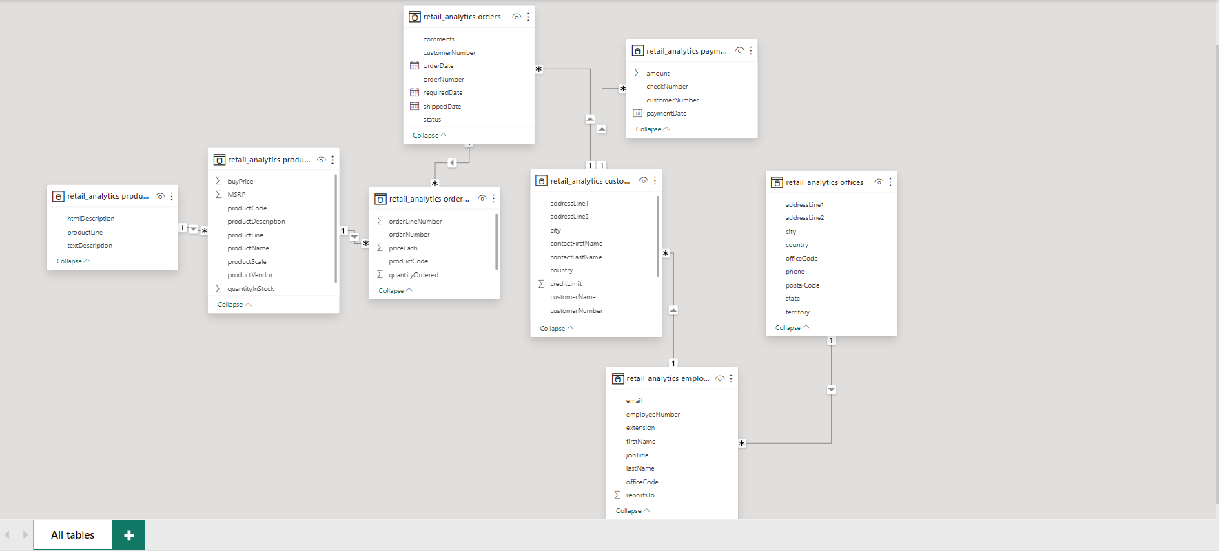

**PROBLEM STATEMENT -1**

1. How does monthly revenue vary across different product categories? (Visual: Monthly revenue by product category)

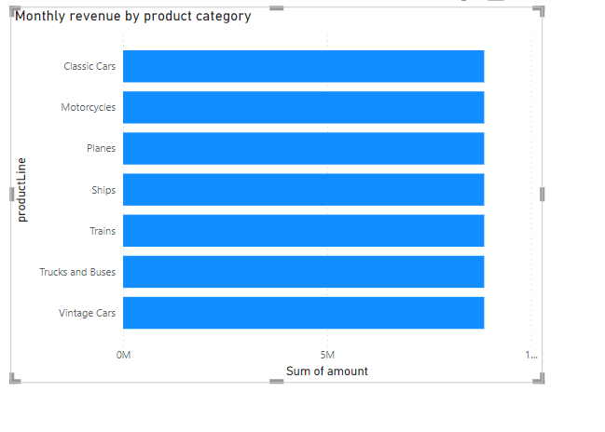

**PROBLEM STATEMENT-2**

What is the trend in customer order volume over the past year? (Visual: Monthly order volume trend)

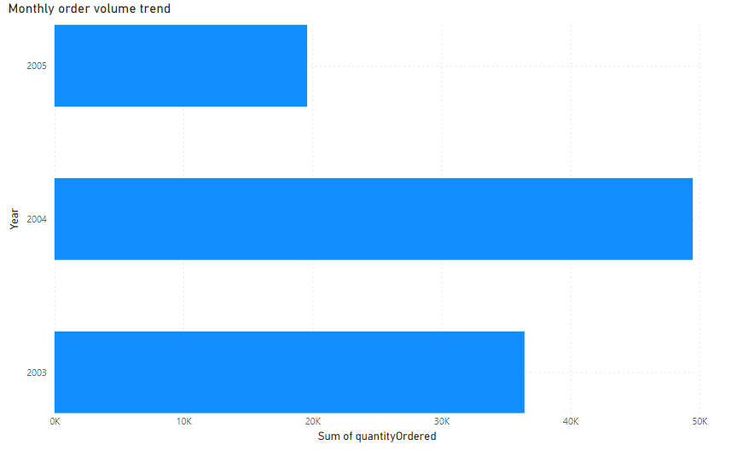

**PROBLEM STATEMENT-3**

How does the sales performance of top customers compare to the rest? (Visual: Sales contribution by top customers vs. others)

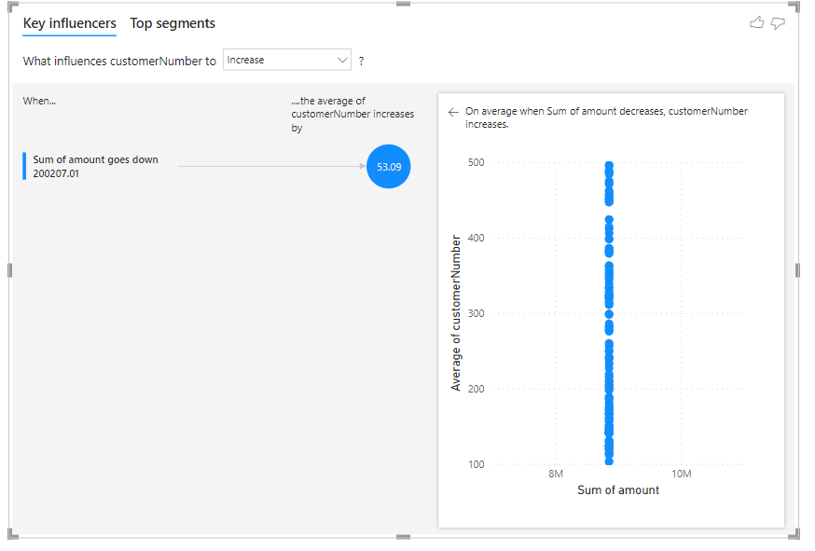

**PROBLEM STATEMENT-4**

What is the distribution of product sales across different product lines? (Visual: Product sales by product line)

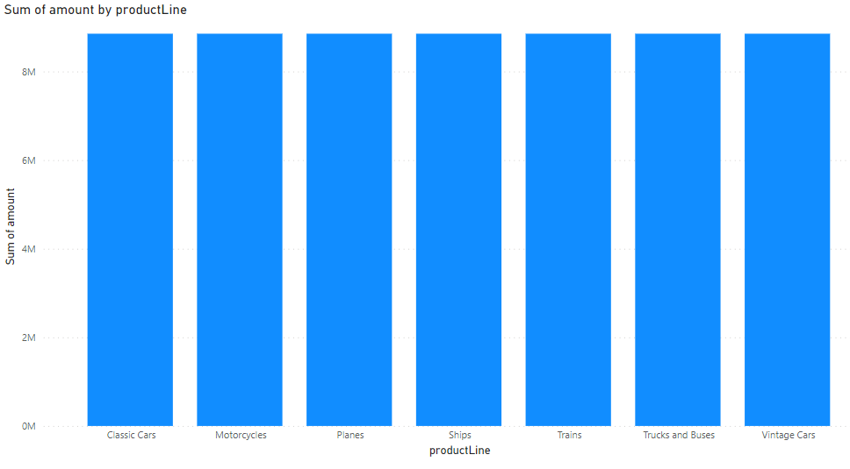

**PROBLEM STATEMENT -5**

How does the profitability of different products compare based on their quantity in stock? (Visual: Profitability vs. quantity in stock)

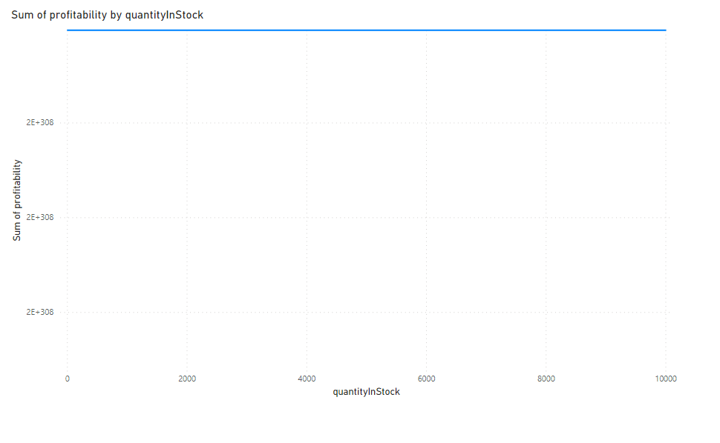

**PROBLEM STATEMENT-6**

How does product pricing impact sales volume? (Visual: Product price vs. sales volume)

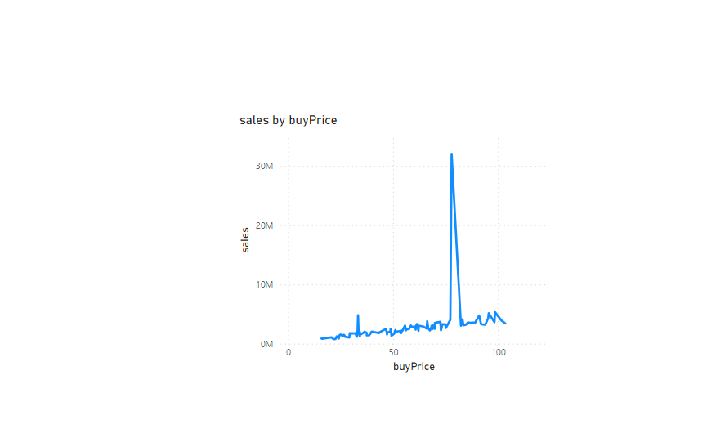

**PROBLEM STATEMENT-7**

What is the distribution of customers across different demographic segments? (Visual: Customer segmentation by demographics)

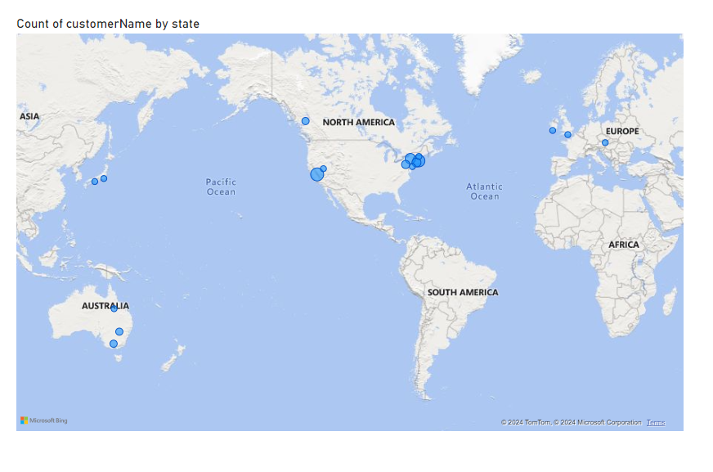

**PROBLEM STATEMENT-8**

How does customer lifetime value vary for different customer acquisition channels? (Visual: CLTV by acquisition channel)

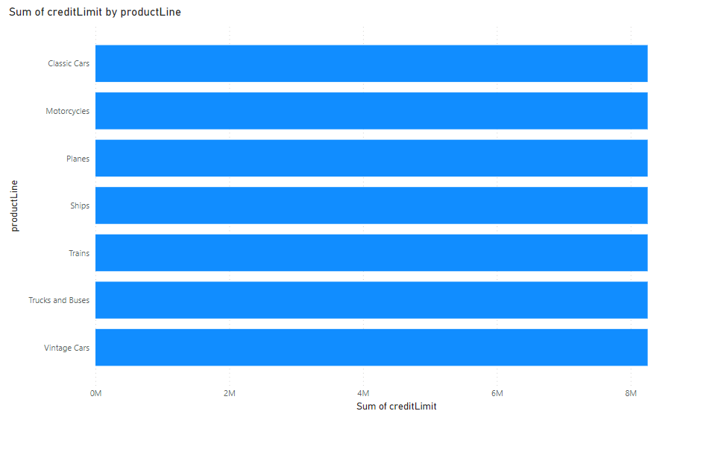

**PROBLEM STATEMENT-9**

What is the correlation between customer age and purchase frequency? (Visual: Customer age vs. purchase frequency)

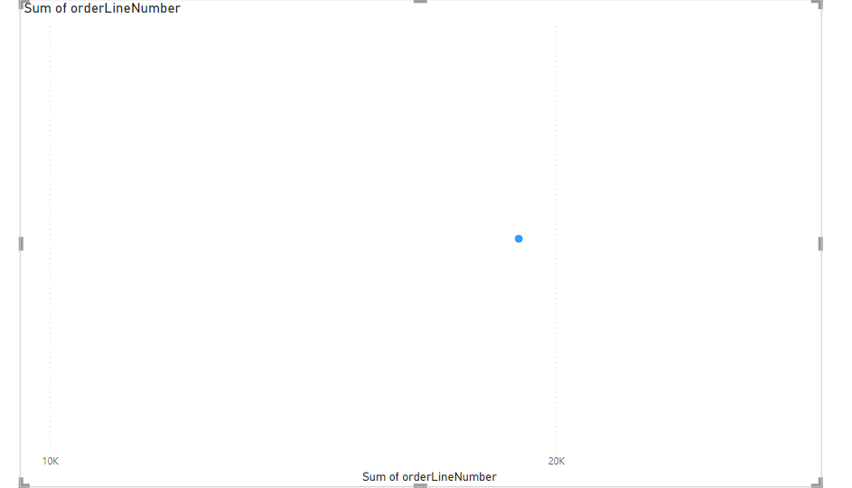

**PROBLEM STATEMENT -10**

What are the top regions in terms of sales revenue? (Visual: Sales revenue by region)

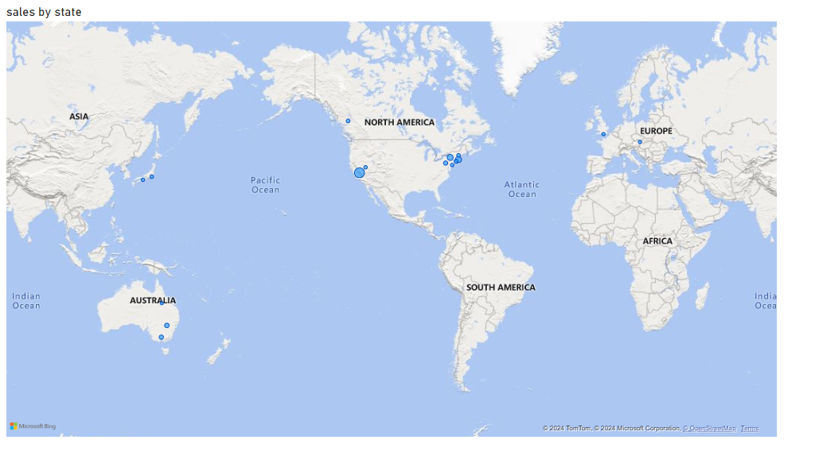

**PROBLEM STATEMENT-11**

How does the performance of sales employees vary across different regions? (Visual: Employee performance by region)

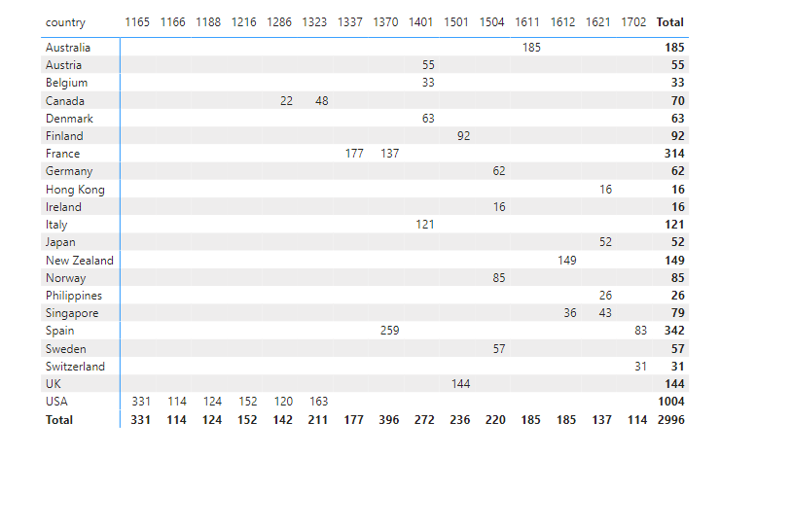

**PROBLEM STATEMENT-12**

What is the correlation between customer demographics and purchase frequency? (Visual: Customer demographics vs. purchase frequency)

